caB2B Web Application Architecture

Document Change History

Version | Date | Contributor | Description
V1.0 | January 23, 2009 | Washington University/Persistent Systems Limited | First Draft

February 26, 2009

Introduction
caB2B web application is a version of caB2B which will expose limited caB2B features to the end-users. caB2B is a client-server application where client is a desktop application implemented in Java-Swings and server deployed in form of enterprise application (EAR) in JBoss.

Why Web Application?
caB2B, though very powerful application, has limitations that it is a thick client, requires setup and configuration on user machines. Also, it may require slightly different setup process on differing architectures. Beside this, the end user needs to get acquainted with certain technical caGrid information and terminologies in order to use the caB2B.
caB2B web application will help in accessing caGrid data, acting as a single access point for all the new users. It will be designed as an extremely user friendly web interface that would help the users to query any available caGrid service. caB2B web application would help simplify the grid terminologies for the end user. A user with little or no knowledge of the caGrid would be able to use the application.
caB2B web application will provide limited functionalities of caB2B in the form of a web application. The advantage is that any new user can use the application without any prior setup and deployment instructions and can still access caGrid data.

The Architectural Principle
Based on the requirement of the caB2B web application we will be using Strut framework which suits and satisfies our needs in following way.

Why Struts?
- We can use caB2B Admin structure or code based on Struts framework which will help us in reducing timeline for development.
- Struts is more widely used than any other framework for J2EE enterprise web applications and have a very strong support.
- Struts provide all the features which are needed by our application and it is certainly extensible.
- Learning and expertise other frameworks (like spring) which may provide same functionalities and has more features will take more time.
The web application will be based on MVC design pattern. MVC pattern defines any application in the form of three layers as shown below. The View and Controller layer interact with each other. Similarly, Controller and Model layer interact with each other.
The View layer as the name suggests should be used to define the visual components of the application. This includes client side view technologies, including HTML, CSS and JavaScript. For, dynamic generation of view components, we will be using JSP templates. View layer, (JSP in our case) should not include any business logic or control flow as they are supposed to be defined in their respective layers Model, and Controller. This loose coupling between different layers helps in making application modular and more maintainable.
Struts provides controller layer in the form of Action classes. An action class interacts with the model and the view. Action class is supposed to have code only for controlling the flow required for calling/updating the model and sending the control to the appropriate view (JSP) along with the results received from the model.

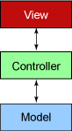
Struts besides helping in separating application design in three maintainable layers also provides solution to certain frequently required needs, like form validation and separation of message resources in View to an external maintainable file. Struts provide ActionForms which are classes helpful in validation and auto filling of form fields in case of any validation error occurs. All this is handled by the Struts itself thus relieving the programmer from reinventing the wheel.
The Model layer defines the business logic. Model layer will interact with the data layer, like databases. Thus, the code for accessing, and manipulating the data layer will be encapsulated by the Model layer. Our project will have this code in the form of EJBs and BizLogic Java classes.
For more details on Struts refer to
http://www.ibm.com/developerworks/webservices/library/ws-arcstruts/
http://struts.apache.org/index.html

Anticipated Technology Stack

Technology | Version | Reason
Java Platform | 1.5 Upgrade 14 | As proposed by caBIG
JBoss | 4.0.5 | As proposed by caBIG
J2EE | 1.4 | As proposed by caBIG
EJB | 2.1 | caB2B Server is using this version and we need to make local calls to caB2B server.
MySQL | 4.1 | caB2B uses dynamic extension in the backend. It is based on this MySQL version
JDBC Driver for MySQL | 3.0.16 GA | caB2B uses dynamic extension in the backend. It is using this version of driver
IE Browser | 6 | Supporting the most widely used browser.
Firefox Browser | 2.0.0.3 | Supporting the most widely used browser.
Safari | 3.1.1 | Supporting the most widely used browser.
HTML | 4.0.1 | Supporting the most widely used browser.
caGrid | 1.2
Ant | 1.6.5 | Can be upgraded to latest one
Subversion (SVN) | YES | As proposed by caBIG
Globus toolkit | 4.0.3 | As proposed by caBIG
Apache Axis | 1.2RC2
Hibernate | 3.0.2 | caB2B uses dynamic extension in the backend. It is based hibernate 3.0.2
JUnit | 3.8.1
Struts Framework | 1.3.5 | As proposed by caBIG

caB2B Web Application High Level Architecture

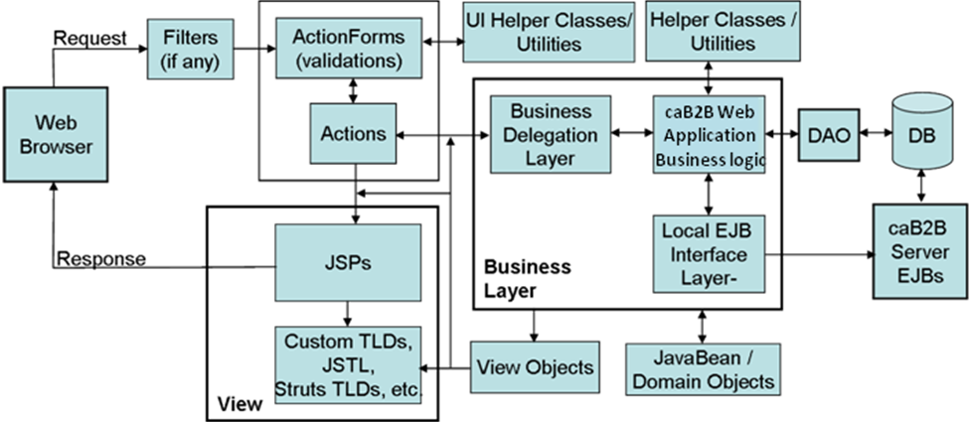
Figure 1 High Level Architecture

Let’s understand this diagram with the help of a use case of query execution. User has selected the query, selected the condition parameters and clicked on Execute button.
Filters: AuthenticationFilter.java: This will connect with caGrid authentication infrastructure to validate the user. User won’t be given access to the welcome page unless he is authenticated. This comes into picture before the user gets access to the application.
ActionForm: ExecuteActionForm.java: This ActionForm class will collect the query id, and the selected attribute conditions from the request
Action: ExecuteQueryAction.java: This class will fetch the query id and the condition values form the ExecuteActionForm which is associated with this action class. Now it will be responsible for calling the interface to the ExecuteBizLogic class.
BusinessDelegationLayer: BusinessFactory.java: This class will invoke the appropriate BusinessLogic class, may it be EJBBusiness interface or local business logic classes. It is introduced to segregate the direct coupling of Action class and BizLogicLayer. In this case it will create an instance of ExecuteQueryBizLogic class and invoke execute(ICab2bQuery) method.
caB2B Business Logic Layer: ExecuteQueryBizLogic: This class will be responsible for fetching the query for given query id and setting the attribute condition in the query. After shaping the query, this call will execute it and return the result to the calling action class.
LocalEJBInterface: This will give call to pre-implemented EJBs present in caB2BServer, if required. In this case ExecuteQueryBizLogic class may invoke execute query method present in QueryEngineBean of caB2BServer.
HelperClasses:
Utility.java: This is a utility class that will provide support functionality like rearranging the data to the business logic layer or presentation layer. In this case, ExecuteQueryBizLogic may call sort(IResult, attribute) method to arrange the records in accending order of given attribute.
UI HelperClasses: Helper classes or Utility classes for presentation layer.
ExecuteQueryAction class may call Utility.convertToTable(IResult), to generate the data in readable form.
JSP: These are the pages that will render the java objects to display content for the browser. Result.jsp: ExecuteQueryAction class will forward the flow to this page, after the data conversion. This will render the result page for the provided data.
Custom TLDs, JSTL, Struts TLDs, etc.: These are the helper for JSPs for rendering the java objects to display content. This may also include AJAX, Javascript or 3rd party display components.
JavaBeans or DomainObjects: They are the data holders or model layer. Cab2bQuery.java that may be shared by presentation layer, business logic layer or DAO layer. Presentation layer uses it to form the display data. Business logic layer sets the parameters in it and uses it to execute the query. DAO layer retreives or save the query into database
DAO Layer: This layer will be called by the business logic layer if needed direct access to the database, in future; otherwise all call to the DB will be routed through caB2BServer.

Sample Local EJB call invocation:
We’ll have following classes for local invocation of QueryEngineBean in caB2BServer

QueryEngineLocalInterface.java
public interface QueryEngineLocalInterface extends EJBLocalObject
implements QueryEngineBusinessInterface {}

QueryEngineLocalHome.java
public interface QueryEngineLocalHome extends EJBLocalHome {
public QueryEngineRemoteInterface create() throws CreateException;
}

Locator.java
public static BusinessInterface locate(String ejbName)
QueryEngineLocalInterface queryEngineHome = null;
try {
Context ic = new InitialContext();
QueryEngineLocalHome home = (QueryEngineLocalHome)
ic.lookup(ejbName);
queryEngineHome = home.create();
} catch (Exception ex) {
out.println(ex);
}
return queryEngineHome;
}

QueryExecuteBizLogic.java
IQueryResult executeQuery(ICab2bQuery query) {
QueryEngineBusinessInterface queryEngineBusinessInterface = (QueryEngineBusinessInterface) Locator.getInstance().locate(QueryEngineBean.class.getName(), QueryEngineLocalHome.class);
IQueryResult result = QueryEngineBusinessInterface.executeQuery(query);
.
.
.
}

Deployment
cab2bWebApp.war will be added to the cab2bServer.ear and will be deployed as a single deployable in JBoss server. This approach will enable us to use the APIs of caB2BServer which are EJBs via EJB local interface. Thus, using the code and also we won’t have to make use of cab2bServer JAR either.

